Final Project for Compiler Design
Karime Leon, Bryce Jimenez, Cherie Atalor, and Wendy Catalanlopez
University of La Verne

Project Overview:
Our team worked on implementing a lexical analyzer, parser, and code generator for arithmetic expressions based on two grammars: a basic grammar and an advanced grammar. The goal was to analyze the input expression 4+7*14+(7+6)*3, parse it according to the grammar, and generate the corresponding intermediate code. The implementation was done in Visual Studio using C++. Each team member was assigned specific tasks to ensure smooth and efficient progress.

1. Lexical Analyzer (Lexer)
The lexical analyzer is the first step in breaking down the input string into meaningful components called tokens. Bryce was primarily responsible for the implementation of the lexical analyzer. The Lexer works by scanning the input string and categorizing characters into tokens. In our case, we defined several token types, such as NUMBER, PLUS, MULTIPLY, LPAREN, RPAREN, and END, to identify numeric literals, operators, parentheses, and the end of input.
The Lexer uses a simple loop to iterate through the input string, checking each character and deciding whether it is part of a number, an operator, or a parenthesis. When a number is encountered, the Lexer parser the entire number and stores it as a token. For operators and parentheses, it recognizes them individually and stores them as their respective tokens. The Lexer also handles whitespaces by skipping them and looking for the next meaningful character.
Bryce’s work on the Lexer ensured that the input expression was correctly tokenized and prepared for the parsing stage. This foundational step made it possible to move forward with parsing and generating intermediate code.

2. Parser and Code Generation
The Parser is responsible for analyzing the sequence of tokens and ensuring that they conform to the grammar rules. Wendy took charge of implementing the Parser. The grammar we used for this task includes rules for parsing expressions (E), terms (T), and factors (F), as described in the project overview. Wendy’s implementation focused on recursively parsing expressions, terms, and factors while respecting operator precedence.
The parser begins by parsing a term, and then continues parsing an expression. For addition and subtraction, it recursively parses terms and generates corresponding intermediate code. Wendy’s Parser handles various operations, such as addition (+) and multiplication (*), ensuring the correct order of operations is respected. If the Parser encounters any unexpected tokens, it generates an error message and halts the execution.
The next step in the process is code generation, which was handled by Cherie. After parsing the tokens and confirming they adhere to the grammar, Cherie’s responsibility was to generate the intermediate code corresponding to the arithmetic operations. For each operation like addition or multiplication, Cherie created temporary variables and stored the intermediate results. The intermediate code is structured in a way that simulates the execution of the expression in a machine-like step-by-step manner. For example, when parsing the expression 4+7*14, Cherie generated code to perform the multiplication first, followed by the addition.
Cherie’s code generation functions create temporary variables to hold intermediate results. When the Parser encounters an operation, Cherie generates an instruction to store the result of that operation in a temporary variable, ensuring that each step of the operation is explicitly represented in the intermediate code.

3. Testing and Integration
Karime was responsible for integrating the Lexer, Parser, and Code Generator. Once the individual components were implemented, Karime ensured they worked together smoothly. This involved testing the entire system with sample inputs, identifying bugs or issues, and making necessary adjustments. Karime also played a key role in running the tests using the input expression 4+7*14+(7+6)*3, which helped verify that the lexer correctly tokenized the input, the parser adhered to the grammar, and the code generator produced the correct intermediate code.
Testing the system was essential to ensure that the implementation was robust. Karime performed a series of tests and debugged any issues that arose during the integration. After testing the system, the intermediate code generated from the input expression was printed, which helped verify the correctness of the parser and code generator.

4. Work Division and Collaboration
The project was divided among the team members in a way that played to each individual’s strengths:
- Bryce focused on developing the Lexical Analyzer (Lexer) and ensuring that the input string was correctly tokenized into distinct token types. This involved handling the identification of numbers, operators, and parentheses.
- Wendy handled the Parser. She implemented the recursive descent parsing technique and made sure the grammar rules were followed for expressions, terms, and factors, all while managing operator precedence.
- Cherie worked on the Code Generator, responsible for creating intermediate code after the parsing stage. She generated code for operations like addition and multiplication, using temporary variables to represent intermediate results.
- Karime coordinated the integration of the components, testing the system, and ensuring that the Lexer, Parser, and Code Generator worked seamlessly together. Karime also handled the final debugging and verification of the system’s functionality.
Each team member communicated regularly, helping with debugging and providing feedback. This division of tasks allowed the team to work efficiently and effectively, ultimately leading to a successful implementation.

5. Screenshots

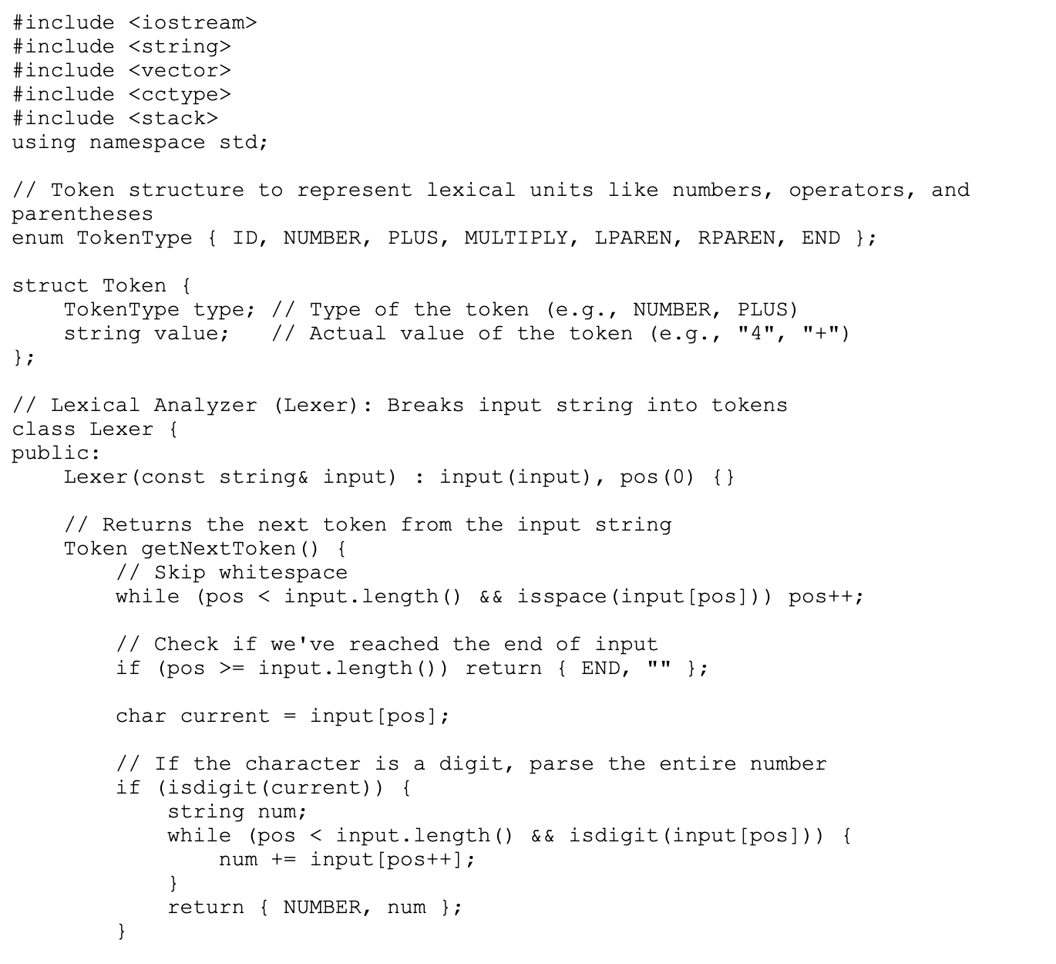

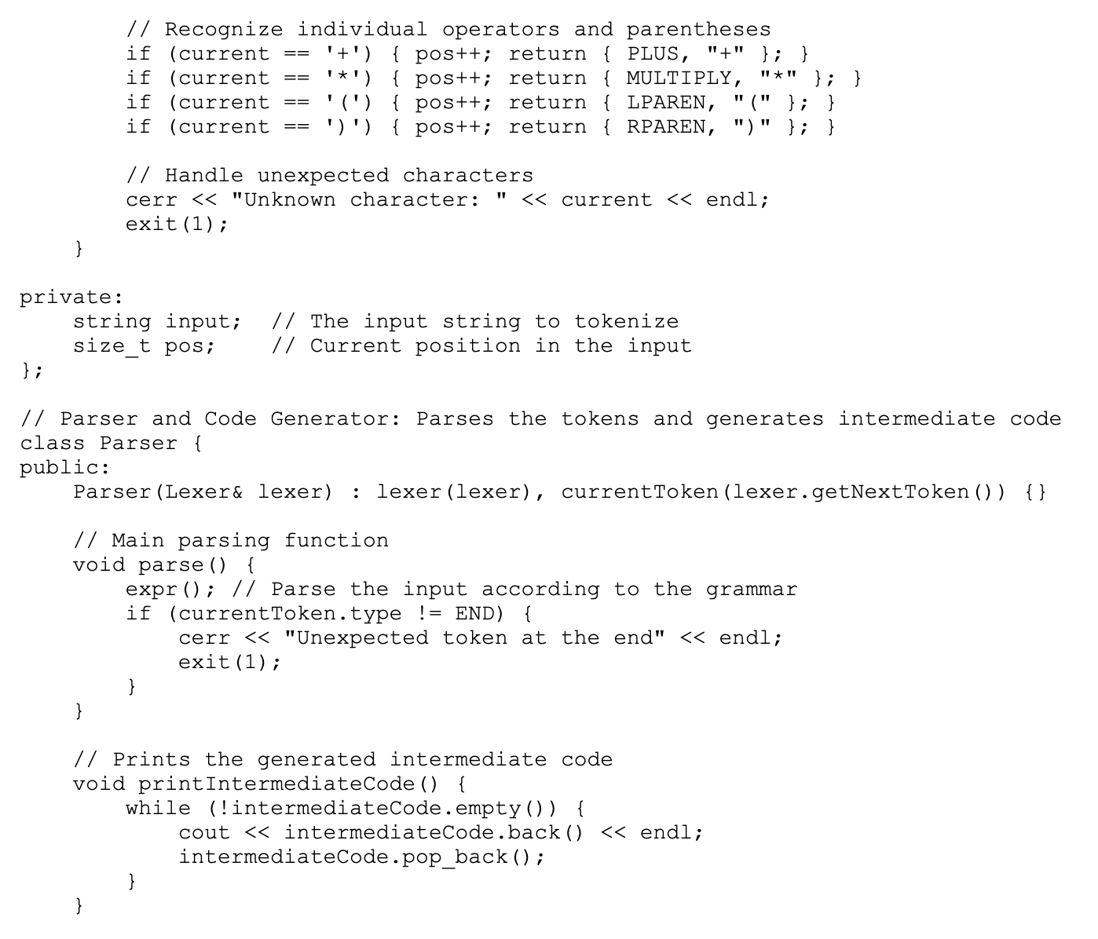
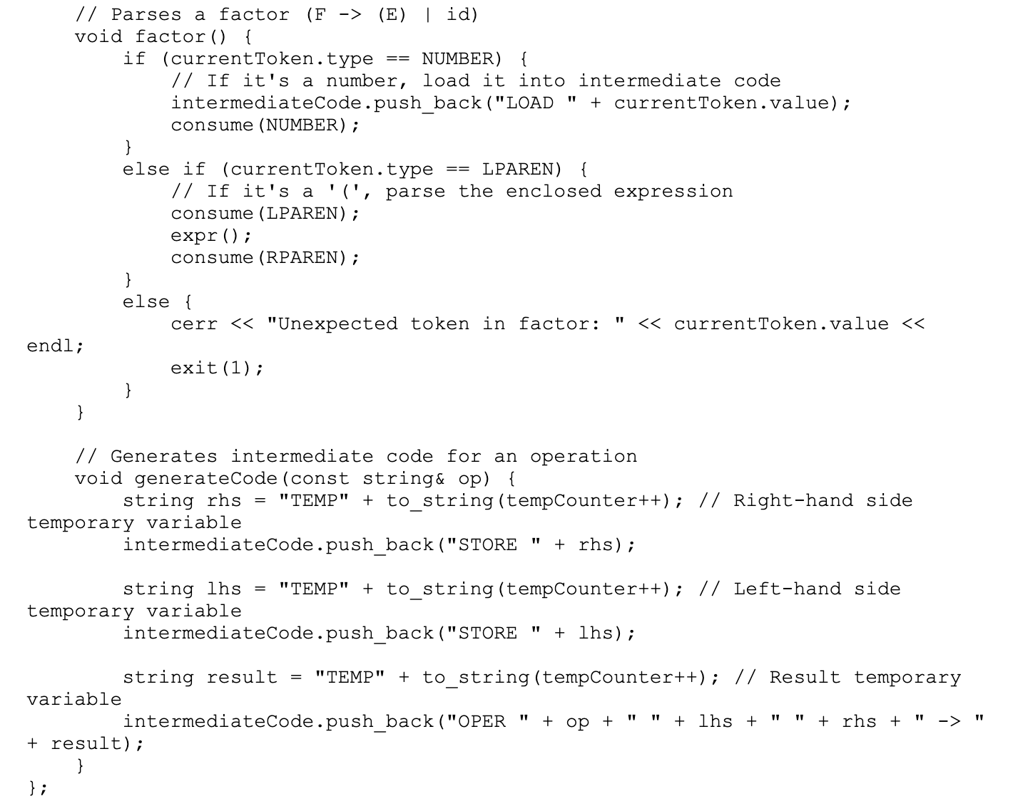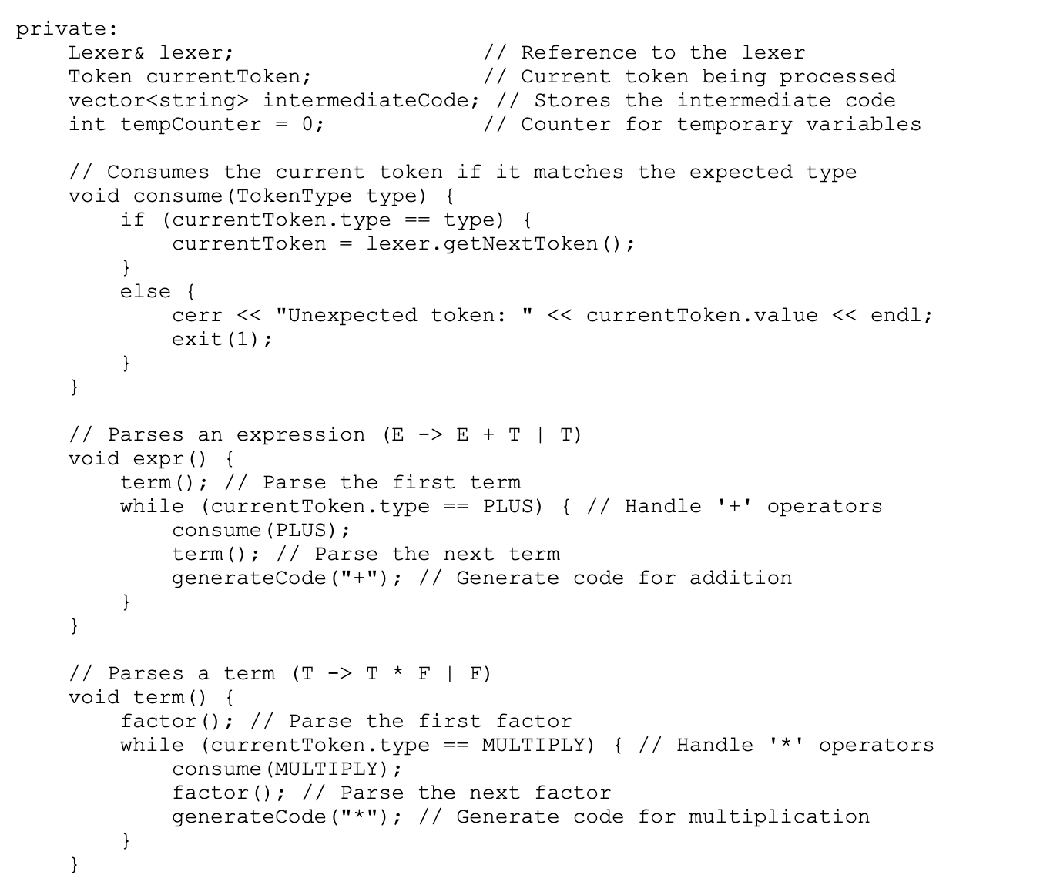
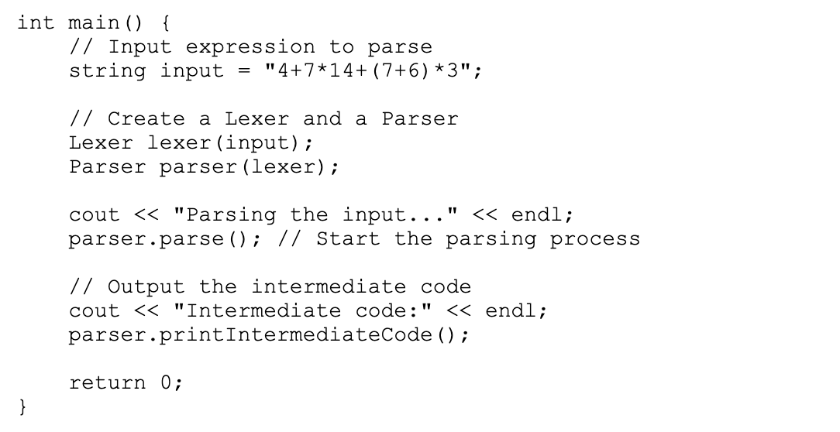
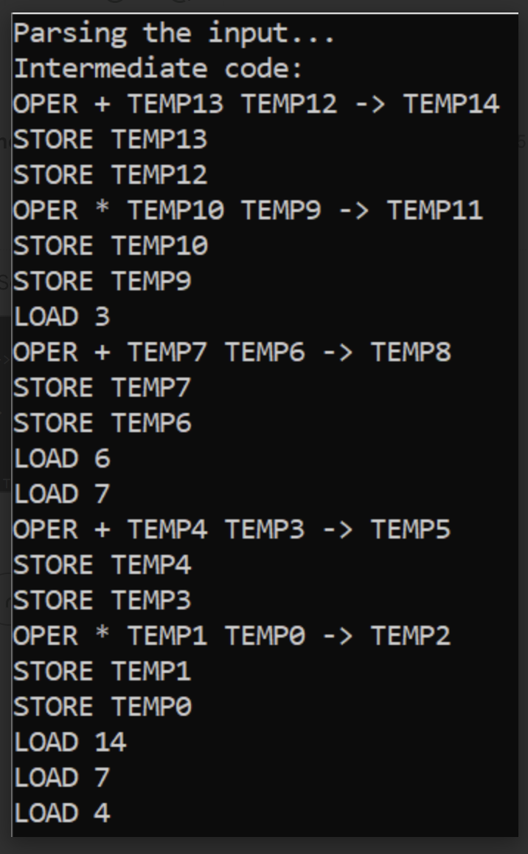

6. Conclusion
In conclusion, the project was completed successfully, and the system was able to parse and generate intermediate code for the arithmetic expression 4+7*14+(7+6)*3. The lexical analyzer correctly tokenized the input, the parser adhered to the grammar rules, and the code generator produced accurate intermediate code. The work was divided efficiently among the team members, each contributing to a specific part of the system. The project provided valuable experience in developing a simple compiler-like system and highlighted the importance of collaboration in software development.
The system could be further extended to handle more complex expressions, additional operators, or even support other features, such as generating machine code or optimizing the intermediate code. The successful implementation of this project demonstrates the importance of careful design and collaboration in building a working system.

